Report on Employee performance dashboard

Name: Praveena. T

Batch Code: TN_DA_FNB07

Contact No: 9790910561

Email ID: praveeflora4703@gmail.com

Project title: Employee performance dashboard

Project Domain: Human Resources

Submission Date: 10/12/2025

Mentor Name: Kumaran. M

Raw dataset link: Messy HR Set

Cleaned dataset : Cleaned report

Github Link: Mini Project

Introduction
This report provides a comprehensive analysis of employee performance, engagement, satisfaction, and training outcomes based on the HR dataset. It summarizes workforce trends, highlights potential areas of concern, and presents dashboard visuals for better decision-making.
Objectives
To provide an overview of the workforce, including active and exited employees.
- To analyze employee performance ratings and identify strengths and gaps.
- To evaluate employee satisfaction and engagement levels.
- To assess attrition trends and identify contributing factors.
- To analyze training investment and its effectiveness.
- To support HR in making data-driven decisions.
- To identify opportunities for improved performance management.
Steps done on the report
- Data cleaning
- Data visualization
- Dashboard
- Data Insights

Data Cleaning
Raw dataset contains lot of inconsistencies like mentioned below.
- First name and last name
Both columns had incorrect format names. So, corrected using proper formula.
=Proper(B2) and created full name using below concatenated formula.
=Concatenate (C3,” “, E3)
- Faced dissimilarities in all date columns. Which corrected using text to column method.
Data – text to column- delimited- next -next – date as DMY and finished.
- Few names in supervisor column contains title as MR, MRS &N DR. Corrected those names using find and replace function.
- Training cost has general format. So, changed the data type as currency using format type option.
- Employee status, termination type and term description contain a blank cell. Which was filled as “active employees” after checked exit date column.
- Exit date contains missing value. Filled as “not needed”. Since, those employees are active.
- Calculated employee age for the analyzing using below formula.
=Datedif(u2,today(),”y”)

Data Visualization
- Created total employee data card using “calculated measure” DAX function.
Total Employee = COUNTROWS('EMP DATA')
- Calcluated male and female employees for dashboard.
Male = CALCULATE(COUNT('EMP DATA'[Employee ID]),'EMP DATA'[GenderCode]="male")
Female = CALCULATE(COUNT('EMP DATA'[Employee ID]),'EMP DATA'[GenderCode]="Female")
- Calculated average training cost to know the amount spent on employee’s knowledge using below DAX function.
Avg trng cost = AVERAGE('EMP DATA'[Training Cost])

- After all these created cards using “new card” option and formatted accordingly.
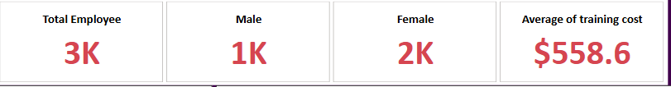
- Created charts using employee feedback metrics to understand the employees needs and thoughts using pie chart.
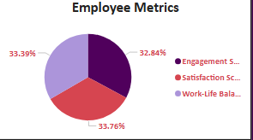

- Created chart using clustered bar to analysis the amount spent on each training program.

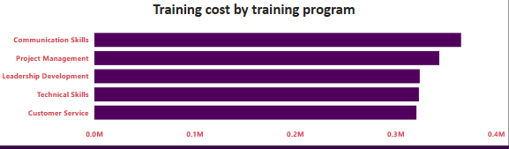

- Used stacked column chart to illustrate the employee status by count.

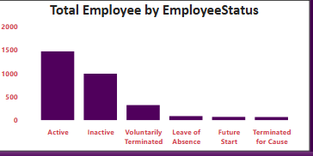

- Demonstrated training outcome using donut chart.

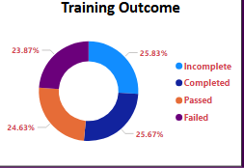

- Illustrated money spent for training depends on duration using line chart.

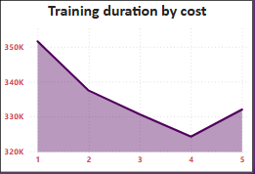

- Created slicers for “Department type” and “state” for review and decision purpose.
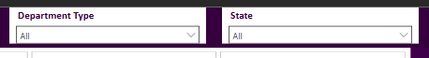

Dashboard
By combining all the above created charts, cards & slicers created the dashboard for employee performance.
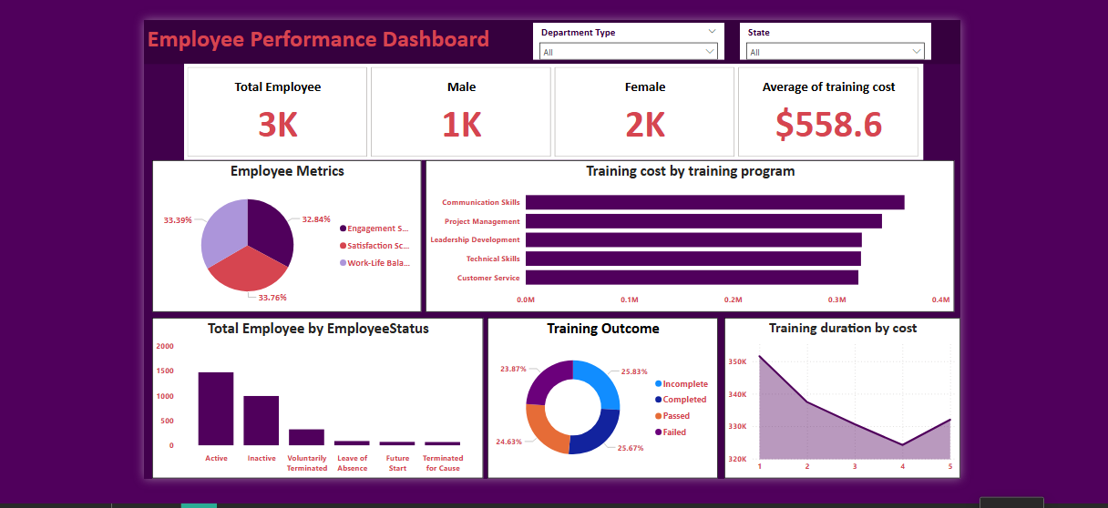

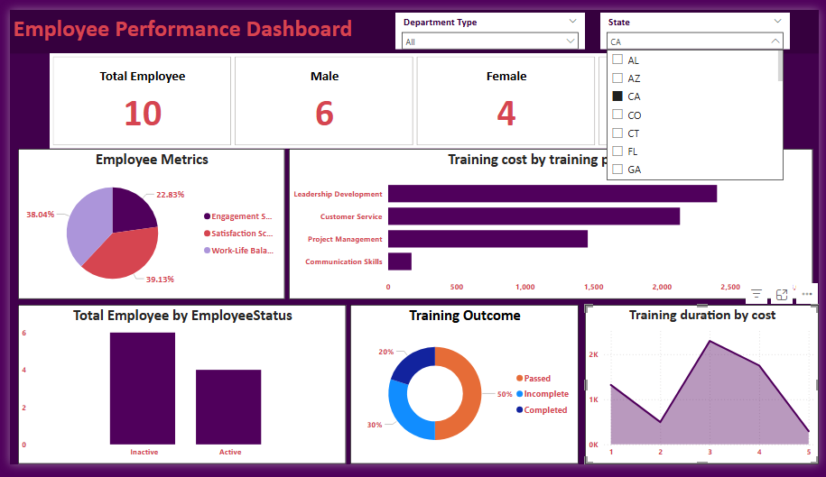
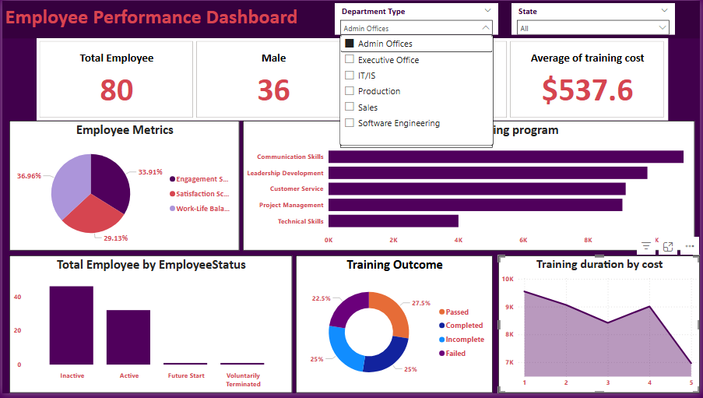
Key Insights
Workforce Composition
- The organization has a total workforce of 3,000 employees, with 1,467 active and 1,533 exited employees.
- This reflects an attrition rate of 51.1%, which is considerably higher than industry benchmarks and signals potential concerns related to employee experience, retention strategies, and workplace culture.
- High turnover may be impacting productivity, continuity, and overall organizational stability.
Performance Trends
- The majority of employees (78.7%) are rated “Fully Meets Expectations,” indicating consistent baseline performance across the organization.
- Only 12.3% of employees achieve an “Exceeds Expectations” rating, representing a limited pool of high performers.
- Approximately 9% of employees fall into the “Needs Improvement” or “PIP” categories, highlighting a segment requiring performance coaching and targeted development interventions.
Employee Satisfaction and Engagement
- The average Satisfaction Score of 3.02/5 indicates moderate employee contentment, with room for improvement in workplace environment and support mechanisms.
- An Engagement Score of 2.94/5 suggests that employees may lack strong connection, motivation, or involvement in organizational goals.
- Both scores likely contribute to the elevated attrition rate and underscore the need for improved engagement strategies.
Training and Development Effectiveness
- The organization invests an average of $558.63 per employee in training initiatives, demonstrating a commitment to skill development.
- However, the limited growth in high-performance ratings indicates potential misalignment between training programs and actual performance needs.
- Re-evaluation of training relevance, delivery methods, and post-training follow-up may be necessary to improve overall training ROI.

Performance Health Overview
- Overall performance stability is evident, but there is a lack of strong differentiation between average and high performers.
- The limited number of exceptional performers highlights opportunities to strengthen recognition programs, leadership support, and targeted development pathways.
Relationship Between Engagement and Retention
- The combination of high attrition and moderate satisfaction/engagement scores strongly suggests challenges in employee experience, management practices, or workplace culture.
- Enhancing communication, recognition, career development, and well-being initiatives will be essential to improving long-term retention.

Conclusion
The Employee Performance Dashboard reveals that attrition levels are significantly high, while performance remains stable for most employees. However, engagement and satisfaction scores indicate areas for improvement. Strengthening performance management, enhancing training effectiveness, and increasing employee engagement efforts will support organizational growth.

